**Module No : 1**

**SE – Overview of IT Industry**

**Q 1 : What is software? What is software engineering?**

**Ans : Software** is a set of instructions, data or programs used to operate computers and execute specific tasks.

**Software Engineering :** The application of a systematic, disciplined, quantifiable approach to the development, operation, and maintenance of software

**Q 2. Explain types of software**

**Ans : 1. Application software** **:** The most common type of software, application software is a computer software package that performs a specific function for a user, or in some cases, for another application. An application can be self-contained, or it can be a group of programs that run the application for the user**2. System software :**These software programs are designed to run a computer's application programs and hardware. System software coordinates the activities and functions of the hardware and software. In addition, it controls the operations of the computer hardware and provides an environment or platform for all the other types of software to work in. The OS is the best example of system software

3. **Driver software.**Also known as device drivers, this software is often considered a type of system software. Device drivers control the devices and peripherals connected to a computer, enabling them to perform their specific tasks.

**4. Middleware** : The term *middleware* describes software that mediates between application and system software or between two different kinds of application software. For example, middleware enables Microsoft Windows to talk to Excel and Word

**5. Programming software** :  Computer programmers use programming software to write code. Programming software and programming tools enable developers to develop, write, test and [debug](https://www.techtarget.com/searchsoftwarequality/definition/debugging) other software programs. Examples of programming software include assemblers, compilers, debuggers and interpreters**.**

**Q 3. What is SDLC? Explain each phase of SDLC**

**Ans :** SDLC (Software Development Life Cycle) is used in Every Software Development Company because it is the root of the Development Cycle

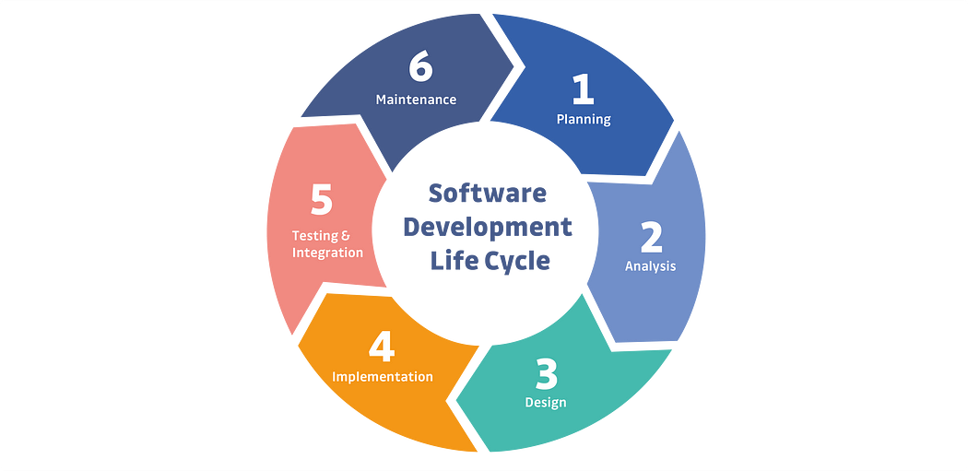

**Phase Of SDLC :**

**1. Requirements gathering and analysis:** This phase involves gathering information about the software requirements from stakeholders, such as customers, end-users, and business analysts.

**2. Design:** In this phase, the software design is created, which includes the overall architecture of the software, data structures, and interfaces.

**It has two steps: 1.High-level design (HLD):** It gives the architecture of software products.

**2. Low-level design (LLD):** It describes how each and every feature in the product should work and every component.

**3. Implementation or coding:** The design is then implemented in code, usually in several iterations, and this phase is also called as Development**.**

**4. Testing:** The software is thoroughly tested to ensure that it meets the requirements and works correctly.

**5. Deployment:** After successful testing, The software is deployed to a production environment and made available to end-users.

**6. Maintenance:** This phase includes ongoing support, bug fixes, and updates to the software.

**Q 4. What is DFD? Create a DFD diagram on Flipkart**

**Ans .** DFD is the abbreviation for Data Flow Diagram. The flow of data of a system or a process is represented by DFD. It also gives insight into the inputs and outputs of each entity and the process itself. DFD does not have control flow and no loops or decision rules are present

Levels of DFD

DFD uses hierarchy to maintain transparency thus multilevel DFD’s can be created. Levels of DFD are as follows:

1. **0-level DFD**: It represents the entire system as a single bubble and provides an overall picture of the system

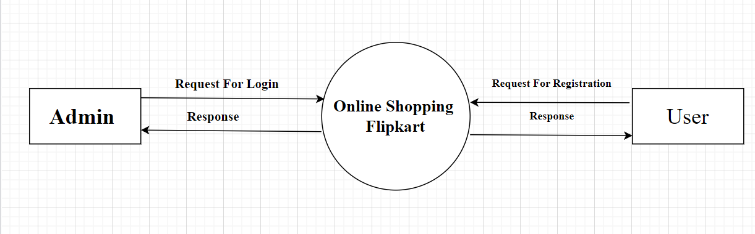**Ex :**

1. **1-level DFD**: It represents the main functions of the system and how they interact with each other.

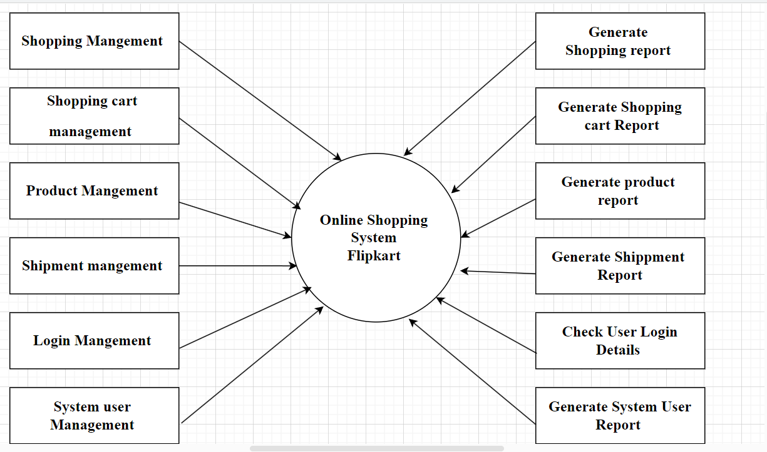**Ex :**

1. **2-level DFD:** It represents the processes within each function of the system and how they interact with each other.

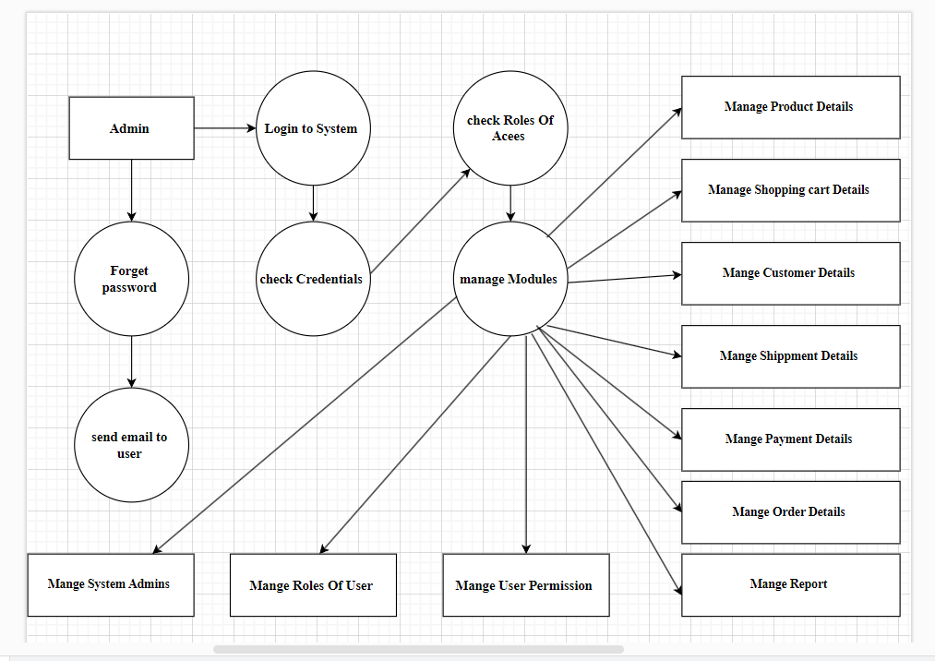**Ex :**

**Q 5. What is Flow chart? Create a flowchart to make addition of two numbers** **?**

**Ans :** flowchart is a type of diagram that represents a workflow or process. A flowchart can also be defined as a diagrammatic representation of an algorithm, a step-by-step approach to solving a task.

* **flowchart addition of two numbers**

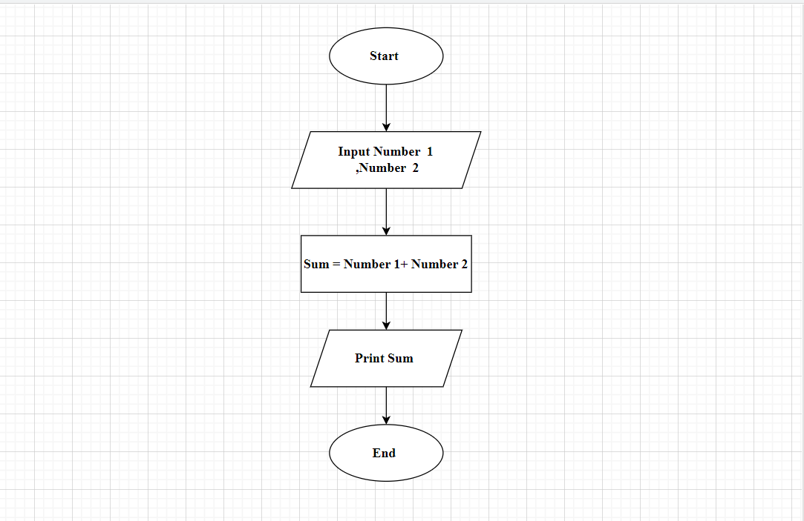

**Q 6. What is Use case Diagram? Create** **a use-case on bill payment on paytm ?**

**Ans :** A Use Case Diagram is a type of Unified Modelling Language (UML) diagram that represents the interaction between actors (users or external systems) and a system under consideration to accomplish specific goals. It provides a high-level view of the system’s functionality by illustrating the various ways users can interact with it.

**\* use-case on bill payment on paytm :**

